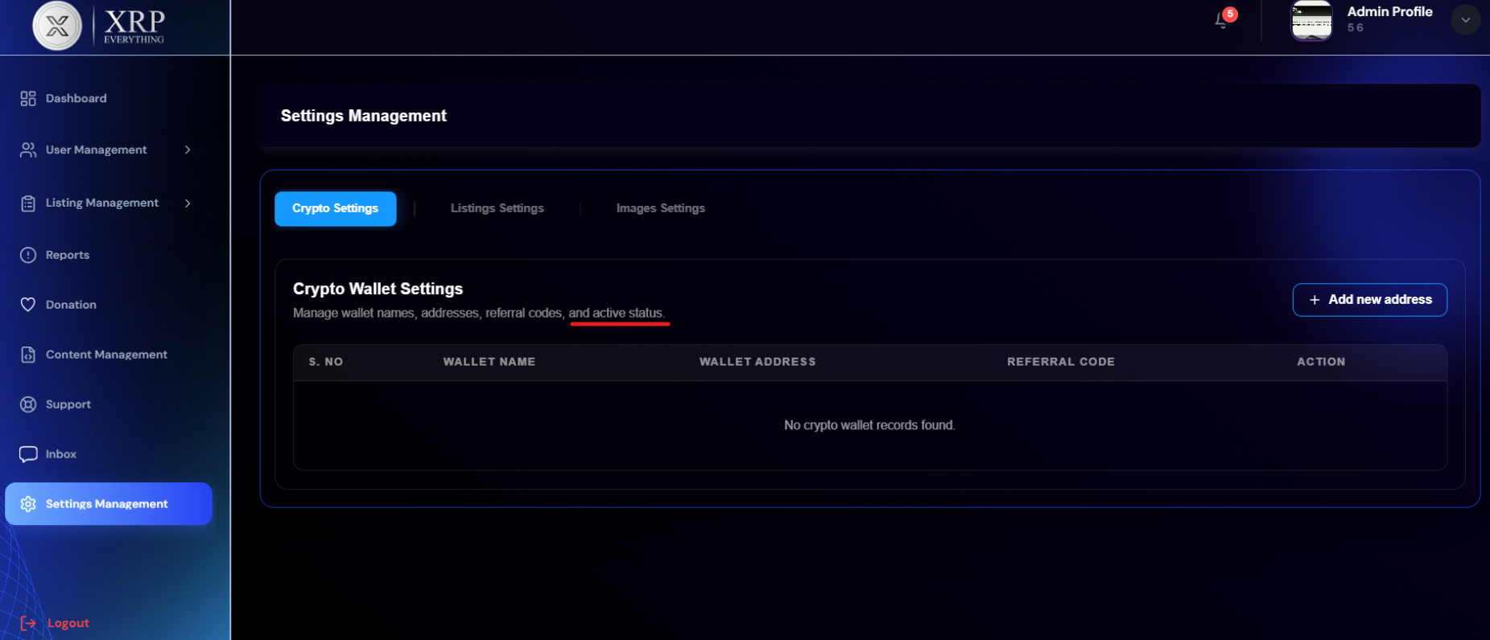
Different page from figma
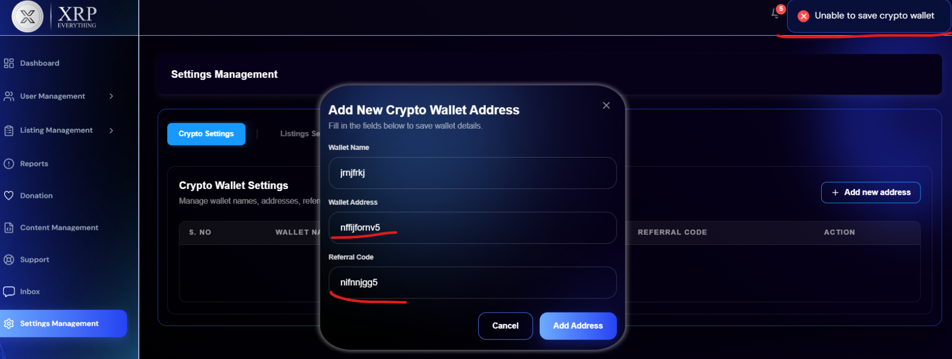
No validation on fields and not adding the wallet

On Listing Settings:
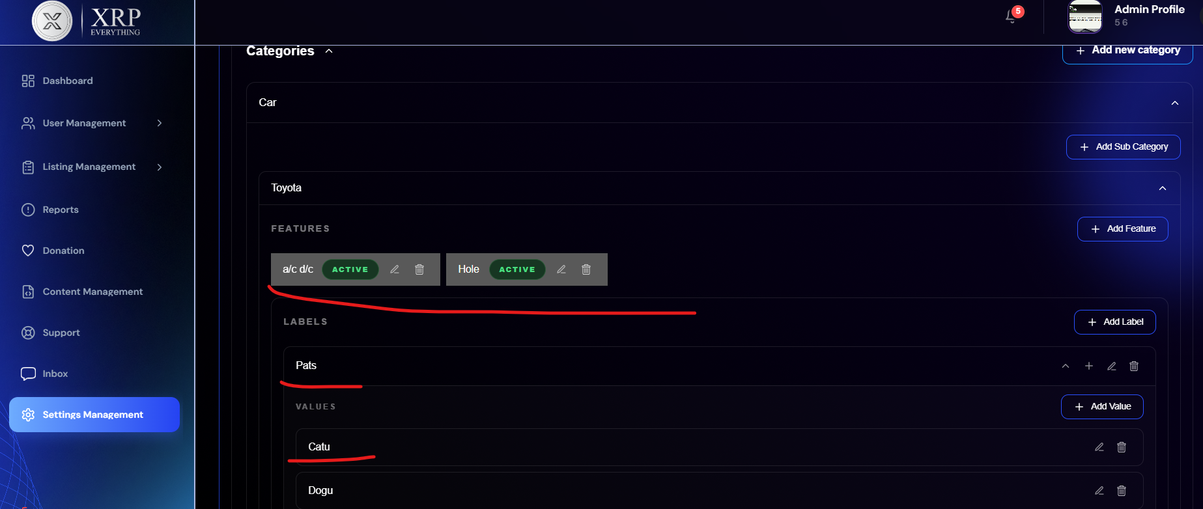
When updating the feature, it shows No features available.
When try to update the labels, it shows error Please fill all required fields
Values fields are not updating
Labels are not deleting
And many other backend issues

